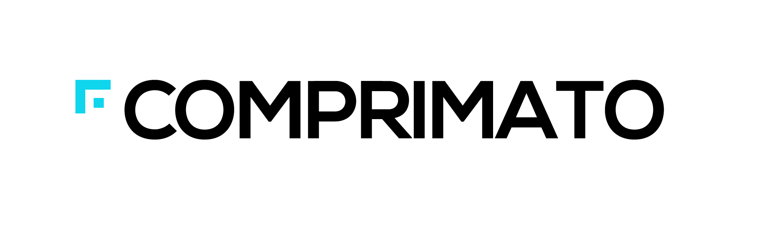
Credo Ventures and Y Soft double down on Comprimato Systems
Brno, September 29th, 2014 – Comprimato, the market leader in JPEG2000 GPU-based compression solutions, has raised € 1,000,000 from existing investors Credo Ventures, Prague-based venture capital firm and Y Soft Venture Capital, a daughter company focused on seed funding established by Y Soft, global provider of scalable print system management solutions.
The investment comes a year after the company has spun off from a Prague-based research institute CESNET and secured its seed financing. Since then Comprimato has delivered its unique compression solution to the digital cinema market and secured numerous major clients including Digimetrics or Stanford University. It is in negotiation with major global players in various fields including military and health applications.
Comprimato’s JPEG2000 encoder and decoder are based on existing mainstream graphics processing units (GPUs) that deliver up to 10x faster JPEG2000 compression compared to existing software solutions at a fraction of the price of custom, single-purpose hardware solutions. Comprimato is headquartered in Cerit Science Park in Brno.
JPEG2000 is a prevalent UHD video codec with wide range of applications from digital cinema & film post production, broadcasting, medical, satellite imagery to defense and government applications.
Jiri Matela, co-founder and the CEO of Comprimato says: “The newly raised capital will allow Comprimato to expand more aggressively on both sales as well as technical side and position ourselves as a leading UHD codec company.”
“Credo is excited to see that its strategy of backing early stage, technology-heavy companies from Central Europe is bearing fruit. Comprimato has proven that using GPUs for compression of UHD media can lead to significant reductions in compression time as well as bandwidth usage and thus generate significant cost savings. We are happy to accelerate company’s development in order to capitalize on the growing applications of UHD video solutions on a global scale“. Said Vladislav Jez, Partner at Credo Ventures.
Ondrej Krajicek of Y Soft Venture Capital: „Y Soft has invested in Comprimato in its second fundraising to further support Comprimato team. We are not investing merely in JPEG2000 codecs on GPUs, but mostly in the development of a team with unique skills and energy, which will make global impact.“
For more information about Comprimato, visit www.comprimato.com
===
About Credo Ventures
Based in Prague, Czech Republic Credo Ventures is a venture capital firm established in 2009 with the goal to become a premiere venture capital firm investing in early stage companies in the fields of Internet, IT and Health in Central Europe. Credo Ventures believes in entrepreneurship and the ability to take Central European projects and companies from zero to success on a global scale. Credo Ventures builds upon strong international relationships; its Advisory Board is headed by technology visionary and investor Esther Dyson and its Investment Committee Chairman is Eduard Mika, one of the most prominent technology entrepreneurs in Central Europe.
For more information, please visit: www.credoventures.com

About Y Soft
Y Soft is a globally operating company that provides scalable print system management solutions (software and hardware) which enable companies and organizations to control costs, reduce waste, increase convenience for users and positively affect the environment.
YSoft SafeQ helps organizations efficiently manage and optimize their reprographic equipment and to track and account every print, copy, and scan by user, department, project, and device. To ensure the most up-to-date technology for its products and services worldwide, Y Soft has strategic alliances with the leading multifunction printer manufacturers, such as Konica Minolta, Xerox, Ricoh, HP, Sharp, and Toshiba. Y Soft also maintains manufacturing and strategic partnerships with all major card reader producers (such as Legic, HID, and Philips) and many minor card reader producers worldwide.
Y Soft Group employs over 180 people, of whom 135 are located in the Czech Republic. Consolidated Group revenues total €11mil / $15mil. For the last 9 years Y Soft has continuously experienced double digit growth. Y Soft exports 90% of its production. Y Soft is headquartered in Brno, Czech Republic, with offices in major regions of Europe, Middle East, North and Latin America, Asia and Australia.
Y Soft Venture Capital has been established in 2012 to support startup projects with interesting technology and global potential. Our goal is to further endorse Y Soft vision of bringing products with high added value developed in Central Europe to the global markets.
For more information, please visit: www.ysoft.com

For press inquiries please contact
Jiri Matela, CEO & Co-Founder, Comprimato, +420 776 121 900, jiri.matela@comprimato.com

